BÀI 1
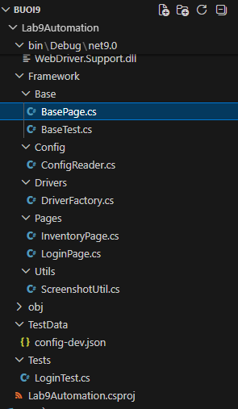
Base[age
using OpenQA.Selenium;
using OpenQA.Selenium.Support.UI;
using SeleniumExtras.WaitHelpers;
using Lab9Automation.Framework.Config;

namespace Lab9Automation.Framework.Base
{
public abstract class BasePage
{
protected readonly IWebDriver driver;
protected readonly WebDriverWait wait;

protected BasePage(IWebDriver driver)
{
this.driver = driver;
wait = new WebDriverWait(driver, TimeSpan.FromSeconds(ConfigReader.ExplicitWait));
}

/// <summary>
/// Chờ phần tử có thể click rồi thực hiện click.
/// </summary>
protected void WaitAndClick(By locator)
{
IWebElement element = wait.Until(ExpectedConditions.ElementToBeClickable(locator));
element.Click();
}

/// <summary>
/// Chờ phần tử hiển thị, xóa dữ liệu cũ rồi nhập dữ liệu mới.
/// </summary>
protected void WaitAndType(By locator, string text)
{
IWebElement element = wait.Until(ExpectedConditions.ElementIsVisible(locator));
element.Clear();
element.SendKeys(text);
}

/// <summary>
/// Lấy text của phần tử sau khi phần tử hiển thị.
/// </summary>
protected string GetText(By locator)
{
IWebElement element = wait.Until(ExpectedConditions.ElementIsVisible(locator));
return element.Text.Trim();
}

/// <summary>
/// Kiểm tra phần tử có hiển thị hay không, có xử lý stale element.
/// </summary>
protected bool IsElementVisible(By locator)
{
try
{
IWebElement element = wait.Until(ExpectedConditions.ElementExists(locator));
return element.Displayed;
}
catch (WebDriverTimeoutException)
{
return false;
}
catch (NoSuchElementException)
{
return false;
}
catch (StaleElementReferenceException)
{
try
{
return driver.FindElement(locator).Displayed;
}
catch
{
return false;
}
}
}

/// <summary>
/// Cuộn đến phần tử bằng JavaScript.
/// </summary>
protected void ScrollToElement(By locator)
{
IWebElement element = wait.Until(ExpectedConditions.ElementExists(locator));
IJavaScriptExecutor js = (IJavaScriptExecutor)driver;
js.ExecuteScript("arguments[0].scrollIntoView({block:'center'});", element);
}

/// <summary>
/// Chờ cho trang load hoàn tất với document.readyState = complete.
/// </summary>
protected void WaitForPageLoad()
{
IJavaScriptExecutor js = (IJavaScriptExecutor)driver;
wait.Until(_ => js.ExecuteScript("return document.readyState")?.ToString() == "complete");
}

/// <summary>
/// Lấy giá trị attribute của phần tử.
/// </summary>
protected string GetAttribute(By locator, string attributeName)
{
IWebElement element = wait.Until(ExpectedConditions.ElementIsVisible(locator));
return element.GetAttribute(attributeName)?.Trim() ?? string.Empty;
}
}
}

BaseTest
using NUnit.Framework;
using NUnit.Framework.Interfaces;
using OpenQA.Selenium;
using Lab9Automation.Framework.Config;
using Lab9Automation.Framework.Drivers;
using Lab9Automation.Framework.Utils;

namespace Lab9Automation.Framework.Base
{
public abstract class BaseTest
{
private static readonly ThreadLocal<IWebDriver?> tlDriver = new();

protected IWebDriver Driver => tlDriver.Value!;

[SetUp]
public void SetUp()
{
string browser = TestContext.Parameters.Get("browser", "chrome");
string env = TestContext.Parameters.Get("env", "dev");

ConfigReader.Load(env);

IWebDriver driver = DriverFactory.CreateDriver(browser);
driver.Manage().Window.Maximize();

tlDriver.Value = driver;

Console.WriteLine($"[DEBUG] BaseUrl = {ConfigReader.BaseUrl}");
Driver.Navigate().GoToUrl(ConfigReader.BaseUrl);
}

[TearDown]
public void TearDown()
{
try
{
if (TestContext.CurrentContext.Result.Outcome.Status == TestStatus.Failed && tlDriver.Value != null)
{
ScreenshotUtil.Capture(Driver, TestContext.CurrentContext.Test.Name);
}
}
finally
{
if (tlDriver.Value != null)
{
tlDriver.Value.Quit();
tlDriver.Value.Dispose();
tlDriver.Value = null;
}
}
}
}
}
loginTesst
using NUnit.Framework;
using Lab9Automation.Framework.Base;
using Lab9Automation.Framework.Pages;

namespace Lab9Automation.Tests
{
[TestFixture]
public class LoginTest : BaseTest
{
[Test]
public void Login_Success()
{
LoginPage loginPage = new LoginPage(Driver);
InventoryPage inventoryPage = loginPage.Login("standard_user", "secret_sauce");

Assert.That(inventoryPage.IsLoaded(), Is.True, "Trang inventory chưa load thành công.");
}

[Test]
public void Login_Fail_With_Wrong_Password()
{
LoginPage loginPage = new LoginPage(Driver);
loginPage.LoginExpectingFailure("standard_user", "wrong_password");

Assert.That(loginPage.IsErrorDisplayed(), Is.True, "Error message không hiển thị.");
}
}
}

Kết quả:
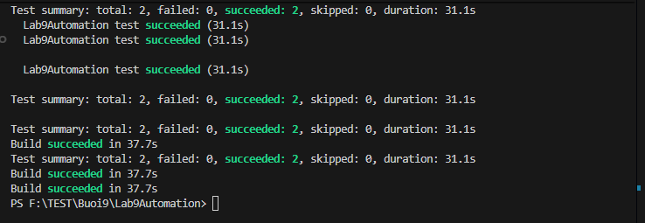
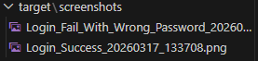
BÀI 2
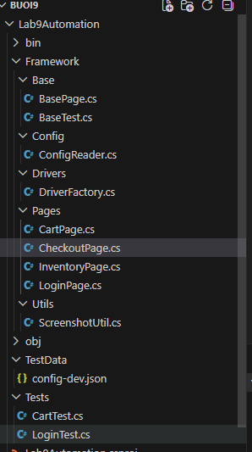
loginPage
using OpenQA.Selenium;
using Lab9Automation.Framework.Base;

namespace Lab9Automation.Framework.Pages
{
public class LoginPage : BasePage
{
private readonly By usernameField = By.Id("user-name");
private readonly By passwordField = By.Id("password");
private readonly By loginButton = By.Id("login-button");
private readonly By errorMessage = By.CssSelector("[data-test='error']");

public LoginPage(IWebDriver driver) : base(driver)
{
}

public InventoryPage Login(string username, string password)
{
WaitAndType(usernameField, username);
WaitAndType(passwordField, password);
WaitAndClick(loginButton);
return new InventoryPage(driver);
}

public LoginPage LoginExpectingFailure(string username, string password)
{
WaitAndType(usernameField, username);
WaitAndType(passwordField, password);
WaitAndClick(loginButton);
return this;
}

public string GetErrorMessage()
{
return GetText(errorMessage);
}

public bool IsErrorDisplayed()
{
return IsElementVisible(errorMessage);
}
}
}
Login test
using NUnit.Framework;
using Lab9Automation.Framework.Base;
using Lab9Automation.Framework.Pages;

namespace Lab9Automation.Tests
{
[TestFixture]
public class CartTest : BaseTest
{
[Test]
public void Add_First_Item_To_Cart_Success()
{
LoginPage loginPage = new LoginPage(Driver);

CartPage cartPage = loginPage
.Login("standard_user", "secret_sauce")
.AddFirstItemToCart()
.GoToCart();

Assert.That(cartPage.GetItemCount(), Is.EqualTo(1));
}

[Test]
public void Add_Item_By_Name_Success()
{
LoginPage loginPage = new LoginPage(Driver);

CartPage cartPage = loginPage
.Login("standard_user", "secret_sauce")
.AddItemByName("Sauce Labs Backpack")
.GoToCart();

Assert.That(cartPage.GetItemCount(), Is.EqualTo(1));
Assert.That(cartPage.GetItemNames(), Does.Contain("Sauce Labs Backpack"));
}

[Test]
public void Remove_First_Item_From_Cart_Success()
{
LoginPage loginPage = new LoginPage(Driver);

CartPage cartPage = loginPage
.Login("standard_user", "secret_sauce")
.AddFirstItemToCart()
.GoToCart()
.RemoveFirstItem();

Assert.That(cartPage.GetItemCount(), Is.EqualTo(0));
}
}
}

Cartpage
using OpenQA.Selenium;
using Lab9Automation.Framework.Base;

namespace Lab9Automation.Framework.Pages
{
public class CartPage : BasePage
{
private readonly By cartItems = By.CssSelector(".cart_item");
private readonly By removeButtons = By.CssSelector(".cart_button");
private readonly By checkoutButton = By.Id("checkout");

public CartPage(IWebDriver driver) : base(driver)
{
}

public int GetItemCount()
{
try
{
var items = driver.FindElements(cartItems);
return items.Count;
}
catch
{
return 0;
}
}

public CartPage RemoveFirstItem()
{
try
{
var buttons = driver.FindElements(removeButtons);
if (buttons.Count > 0)
{
buttons[0].Click();
}
}
catch
{
}

return this;
}

public CheckoutPage GoToCheckout()
{
WaitAndClick(checkoutButton);
return new CheckoutPage(driver);
}

public List<string> GetItemNames()
{
List<string> names = new List<string>();

try
{
var items = driver.FindElements(cartItems);
foreach (var item in items)
{
string name = item.FindElement(By.CssSelector(".inventory_item_name")).Text.Trim();
names.Add(name);
}
}
catch
{
}

return names;
}
}
}

Carttest
using NUnit.Framework;
using Lab9Automation.Framework.Base;
using Lab9Automation.Framework.Pages;

namespace Lab9Automation.Tests
{
[TestFixture]
public class CartTest : BaseTest
{
[Test]
public void Add_First_Item_To_Cart_Success()
{
LoginPage loginPage = new LoginPage(Driver);

CartPage cartPage = loginPage
.Login("standard_user", "secret_sauce")
.AddFirstItemToCart()
.GoToCart();

Assert.That(cartPage.GetItemCount(), Is.EqualTo(1));
}

[Test]
public void Add_Item_By_Name_Success()
{
LoginPage loginPage = new LoginPage(Driver);

CartPage cartPage = loginPage
.Login("standard_user", "secret_sauce")
.AddItemByName("Sauce Labs Backpack")
.GoToCart();

Assert.That(cartPage.GetItemCount(), Is.EqualTo(1));
Assert.That(cartPage.GetItemNames(), Does.Contain("Sauce Labs Backpack"));
}

[Test]
public void Remove_First_Item_From_Cart_Success()
{
LoginPage loginPage = new LoginPage(Driver);

CartPage cartPage = loginPage
.Login("standard_user", "secret_sauce")
.AddFirstItemToCart()
.GoToCart()
.RemoveFirstItem();

Assert.That(cartPage.GetItemCount(), Is.EqualTo(0));
}
}
}

Kết quả:
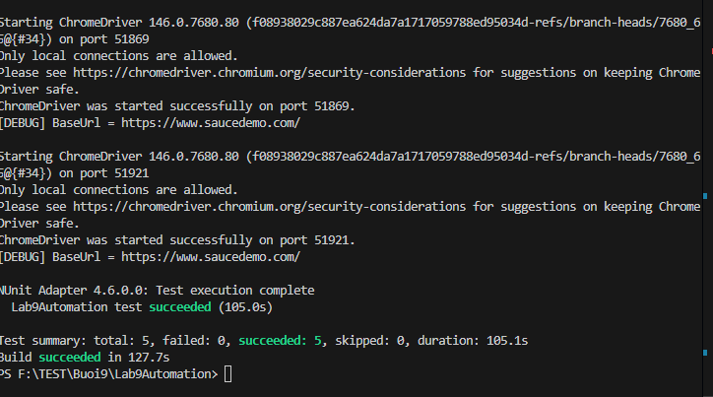

BÀI 3:
CÀI THÊM PAKAGE:
dotnet add package NPOI
dotnet add package NPOI.OOXML
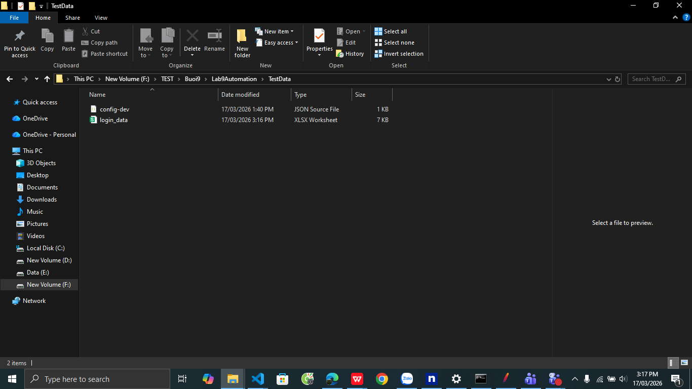
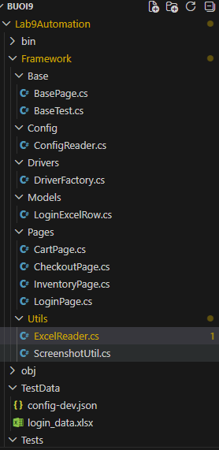
Cartpage
using OpenQA.Selenium;
using Lab9Automation.Framework.Base;

namespace Lab9Automation.Framework.Pages
{
public class CartPage : BasePage
{
private readonly By cartItems = By.CssSelector(".cart_item");
private readonly By removeButtons = By.CssSelector(".cart_button");
private readonly By checkoutButton = By.Id("checkout");

public CartPage(IWebDriver driver) : base(driver)
{
}

public int GetItemCount()
{
try
{
var items = driver.FindElements(cartItems);
return items.Count;
}
catch
{
return 0;
}
}

public CartPage RemoveFirstItem()
{
try
{
var buttons = driver.FindElements(removeButtons);
if (buttons.Count > 0)
{
buttons[0].Click();
}
}
catch
{
}

return this;
}

public CheckoutPage GoToCheckout()
{
WaitAndClick(checkoutButton);
return new CheckoutPage(driver);
}

public List<string> GetItemNames()
{
List<string> names = new List<string>();

try
{
var items = driver.FindElements(cartItems);
foreach (var item in items)
{
string name = item.FindElement(By.CssSelector(".inventory_item_name")).Text.Trim();
names.Add(name);
}
}
catch
{
}

return names;
}
}
}

Carttest
using NUnit.Framework;
using Lab9Automation.Framework.Base;
using Lab9Automation.Framework.Pages;

namespace Lab9Automation.Tests
{
[TestFixture]
public class CartTest : BaseTest
{
[Test]
public void Add_First_Item_To_Cart_Success()
{
LoginPage loginPage = new LoginPage(Driver);

CartPage cartPage = loginPage
.Login("standard_user", "secret_sauce")
.AddFirstItemToCart()
.GoToCart();

Assert.That(cartPage.GetItemCount(), Is.EqualTo(1));
}

[Test]
public void Add_Item_By_Name_Success()
{
LoginPage loginPage = new LoginPage(Driver);

CartPage cartPage = loginPage
.Login("standard_user", "secret_sauce")
.AddItemByName("Sauce Labs Backpack")
.GoToCart();

Assert.That(cartPage.GetItemCount(), Is.EqualTo(1));
Assert.That(cartPage.GetItemNames(), Does.Contain("Sauce Labs Backpack"));
}

[Test]
public void Remove_First_Item_From_Cart_Success()
{
LoginPage loginPage = new LoginPage(Driver);

CartPage cartPage = loginPage
.Login("standard_user", "secret_sauce")
.AddFirstItemToCart()
.GoToCart()
.RemoveFirstItem();

Assert.That(cartPage.GetItemCount(), Is.EqualTo(0));
}
}
}

Checkoutpage
using OpenQA.Selenium;
using Lab9Automation.Framework.Base;

namespace Lab9Automation.Framework.Pages
{
public class CheckoutPage : BasePage
{
public CheckoutPage(IWebDriver driver) : base(driver)
{
}
}
}

Excelreder
using NPOI.SS.UserModel;
using NPOI.XSSF.UserModel;
using Lab9Automation.Models;

namespace Lab9Automation.Framework.Utils
{
public class ExcelReader
{
public static List<LoginExcelRow> ReadLoginData(string filePath, string sheetName)
{
List<LoginExcelRow> rows = new List<LoginExcelRow>();

using FileStream fs = new FileStream(filePath, FileMode.Open, FileAccess.Read);
IWorkbook workbook = new XSSFWorkbook(fs);
ISheet? sheet = workbook.GetSheet(sheetName);

if (sheet == null)
throw new Exception($"Không tìm thấy sheet: {sheetName}");

IRow? headerRow = sheet.GetRow(0);
if (headerRow == null)
throw new Exception($"Sheet {sheetName} không có header.");

Dictionary<string, int> columnIndexes = new Dictionary<string, int>(StringComparer.OrdinalIgnoreCase);

for (int i = 0; i < headerRow.LastCellNum; i++)
{
string header = GetCellValue(headerRow.GetCell(i));
if (!string.IsNullOrWhiteSpace(header))
{
columnIndexes[header.Trim()] = i;
}
}

for (int r = 1; r <= sheet.LastRowNum; r++)
{
IRow? row = sheet.GetRow(r);
if (row == null) continue;

LoginExcelRow data = new LoginExcelRow
{
Username = GetValue(row, columnIndexes, "username"),
Password = GetValue(row, columnIndexes, "password"),
ExpectedUrl = GetValue(row, columnIndexes, "expected_url"),
ExpectedError = GetValue(row, columnIndexes, "expected_error"),
Description = GetValue(row, columnIndexes, "description")
};

if (string.IsNullOrWhiteSpace(data.Description))
{
data.Description = $"{sheetName}_Row_{r}";
}

rows.Add(data);
}

return rows;
}

private static string GetValue(IRow row, Dictionary<string, int> columns, string name)
{
if (!columns.ContainsKey(name)) return "";
return GetCellValue(row.GetCell(columns[name]));
}

public static string GetCellValue(ICell? cell)
{
if (cell == null) return "";

switch (cell.CellType)
{
case CellType.String:
return cell.StringCellValue.Trim();

case CellType.Numeric:
if (DateUtil.IsCellDateFormatted(cell))
{
return cell.DateCellValue.ToString();
}

double num = cell.NumericCellValue;
return num % 1 == 0
? ((long)num).ToString()
: num.ToString();

case CellType.Boolean:
return cell.BooleanCellValue.ToString();

case CellType.Formula:
switch (cell.CachedFormulaResultType)
{
case CellType.String:
return cell.StringCellValue.Trim();

case CellType.Numeric:
double val = cell.NumericCellValue;
return val % 1 == 0
? ((long)val).ToString()
: val.ToString();

case CellType.Boolean:
return cell.BooleanCellValue.ToString();

default:
return "";
}

default:
return "";
}
}
}
}

Kết quả:
